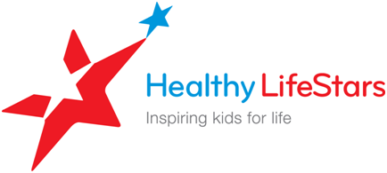

Dear Parent,

Welcome to The LifeStar Challenge!

Healthy LifeStars and the (Organization) are excited to bring The LifeStar Challenge to your community.

This fun program teaches kids some very important things about living healthy, active lives and provides them with tools to help them continue on that journey as they grow.

The (Organization) will be offering a (fill in the blank) week program, which begins by teaching your kids about goal setting. They will learn how to set goals and how to meet the goals.

Your son/daughter will learn about Healthy LifeStars three Healthy Life Habits:

**I Can Do It! -** How to set and achieve personal health goals.

**I’m Active! -** How to include vigorous physical activity into my life every day.

**I Eat Right! -** How to eat the right foods in the right amounts.

Each session the kids will cover different health topics. At the end of the program, the kids are asked to make a commitment to live an active, healthy life now and in the future.

You have a big role in your child’s healthy living! Here are the things you need to do for your child to be a part of the Healthy LifeStars program.

* Please sign the attached permission form and return it to (Coach name).
* Please help and support your child (children) to make healthy choices for snacks and meals.

As always, your Coach, (Coach Name and Contact), and Healthy LifeStars are here to help your kids become the true LifeStars they want to be!

Sincerely,

The LifeStar Challenge Team